PHOTO'S BY ALAN STRUTT
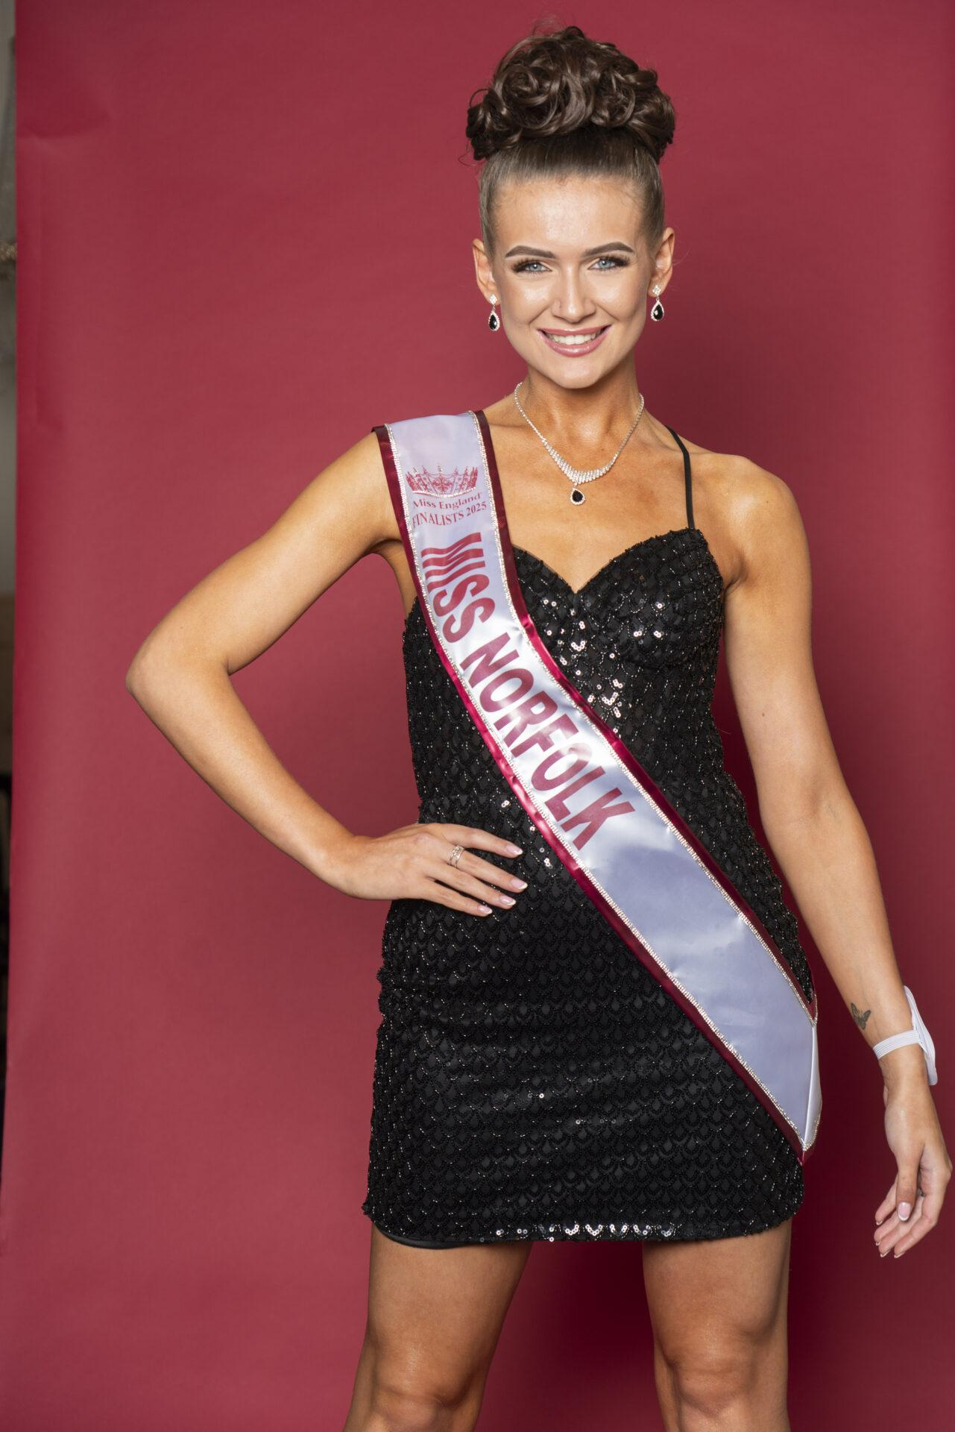
A new chapter in Norfolk's pageant history has officially begun as organisers launch Miss Norfolk, the county's official qualifying competition for the prestigious Miss England pageant.

The newly established contest will provide young women from across Norfolk with the opportunity to represent their county on the national stage, with the eventual winner progressing to the Miss England Grand Final. The winner of Miss England then goes on to represent the nation at the internationally renowned Miss World competition.

The launch follows the crowning of Millie Suiter, originally from King's Lynn, as Miss Norfolk 2025. Millie has proudly represented the county throughout her reign and now prepares to pass on the title as organisers begin the search for her successor.
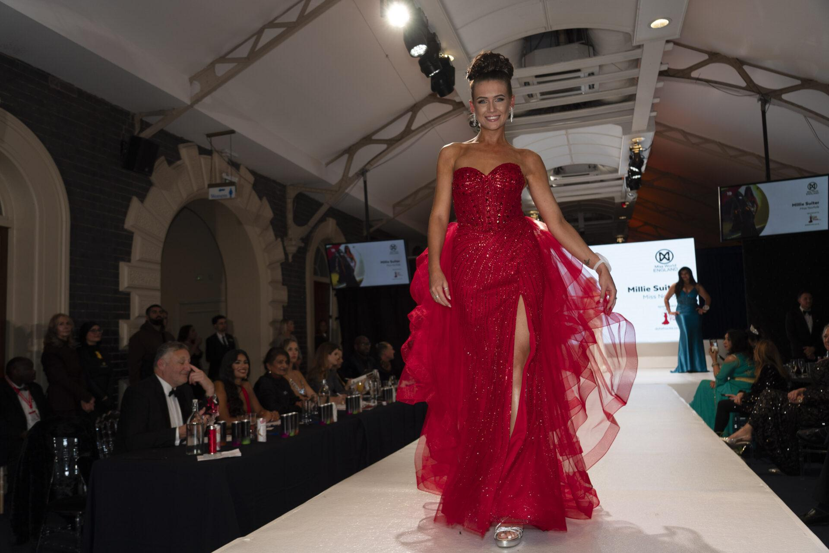
Millie Suiter, Miss Norfolk 2025, said: "Being crowned Miss Norfolk has been an incredible experience and one that I will treasure forever. The opportunities I have been given, the people I have met and the confidence I have gained have been truly life-changing.”

I would encourage anyone who has ever considered entering to take that leap of faith. Miss Norfolk is about so much more than a crown – it's about personal growth, creating lifelong friendships and having a platform to make a difference. I can't wait to see who will be crowned as my successor.”

Entries for Miss Norfolk 2026 will open shortly, with contestants from across the county invited to take part in a competition that celebrates beauty with a purpose, confidence, ambition, community involvement and personal achievement.

The Miss England organisation has become one of the most respected pageant systems in the world, focusing heavily on charity work, advocacy, fundraising and empowering young women to become role models within their communities.

The current Miss England, Grace Richardson, made history when she was crowned at the national final in Wolverhampton in 2025. The Leicester performing arts student has received widespread praise for promoting inclusivity, authenticity and self-confidence.

Grace Richardson, Miss England 2025 said: "Winning Miss England has been one of the proudest moments of my life. The competition has given me a voice, opportunities I could only have dreamed of and the chance to inspire others to be themselves unapologetically.

"The launch of Miss Norfolk is incredibly exciting and I would encourage young women across the county to get involved. You never know where the journey could take you. Miss England changed my life, and it could change yours too.”
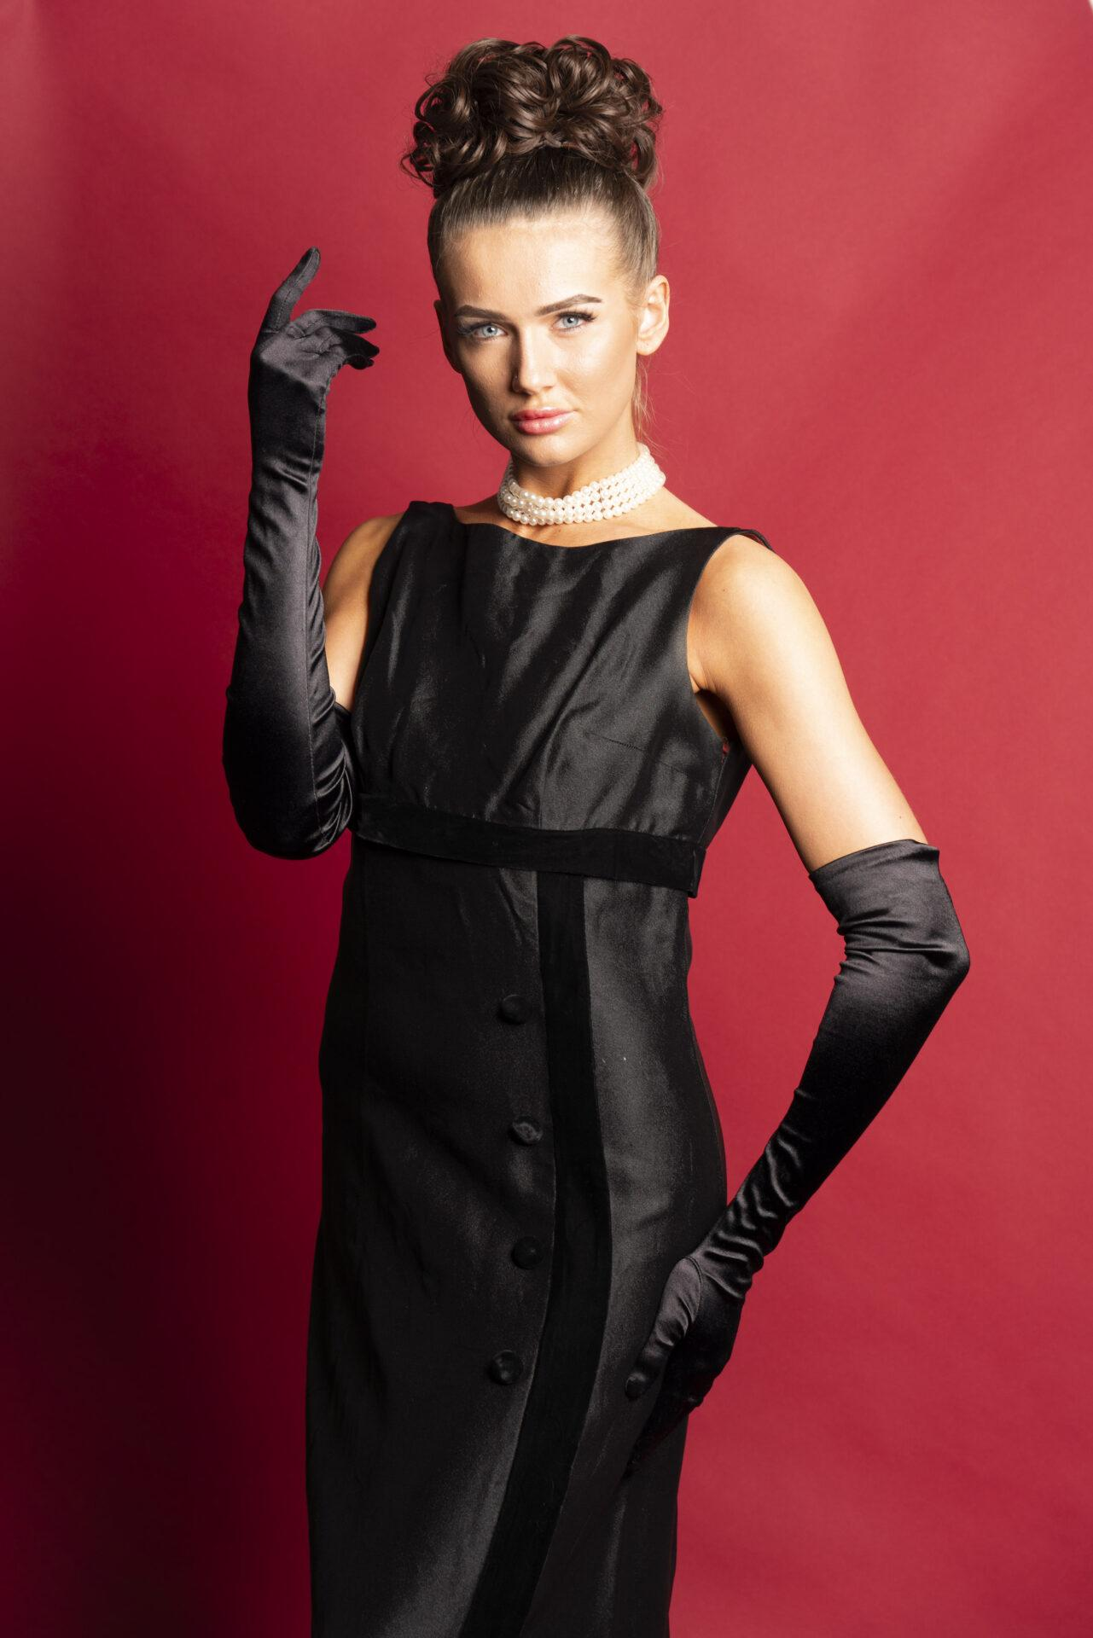
Angie Beasley, Director of Miss England, said: "Miss England has always been about far more than appearance. We are looking for young women who are passionate, driven, compassionate and committed to making a positive difference in their communities.”

I am delighted to see the launch of Miss Norfolk and look forward to welcoming the county's future representatives to the Miss England family. Norfolk is home to so many talented and inspiring young women, and I have no doubt that this competition will uncover some incredible ambassadors for the county.”

The Miss Norfolk competition is organised by Elise Joy Limited, which is also responsible for delivering technical production and event management support across the Miss England Semi-Finals and Grand Finals.

Elise Joy Limited has worked within the Miss England system for the past six years, providing trusted production, technical and operational support at both semi-final and national final level.

Nathan Bryant, Executive Director, Elise Joy Limited said: “Launching Miss Norfolk is a really exciting moment for our team. Having supported the Miss England Semi-Finals and Grand Finals for the past six years, we understand the scale, professionalism and care that goes into this contest.“

We are incredibly proud to now be leading Miss Norfolk and building a platform that gives young women across Norfolk the opportunity to shine. We are excited to begin this new contest and develop it into something truly special for the county.”
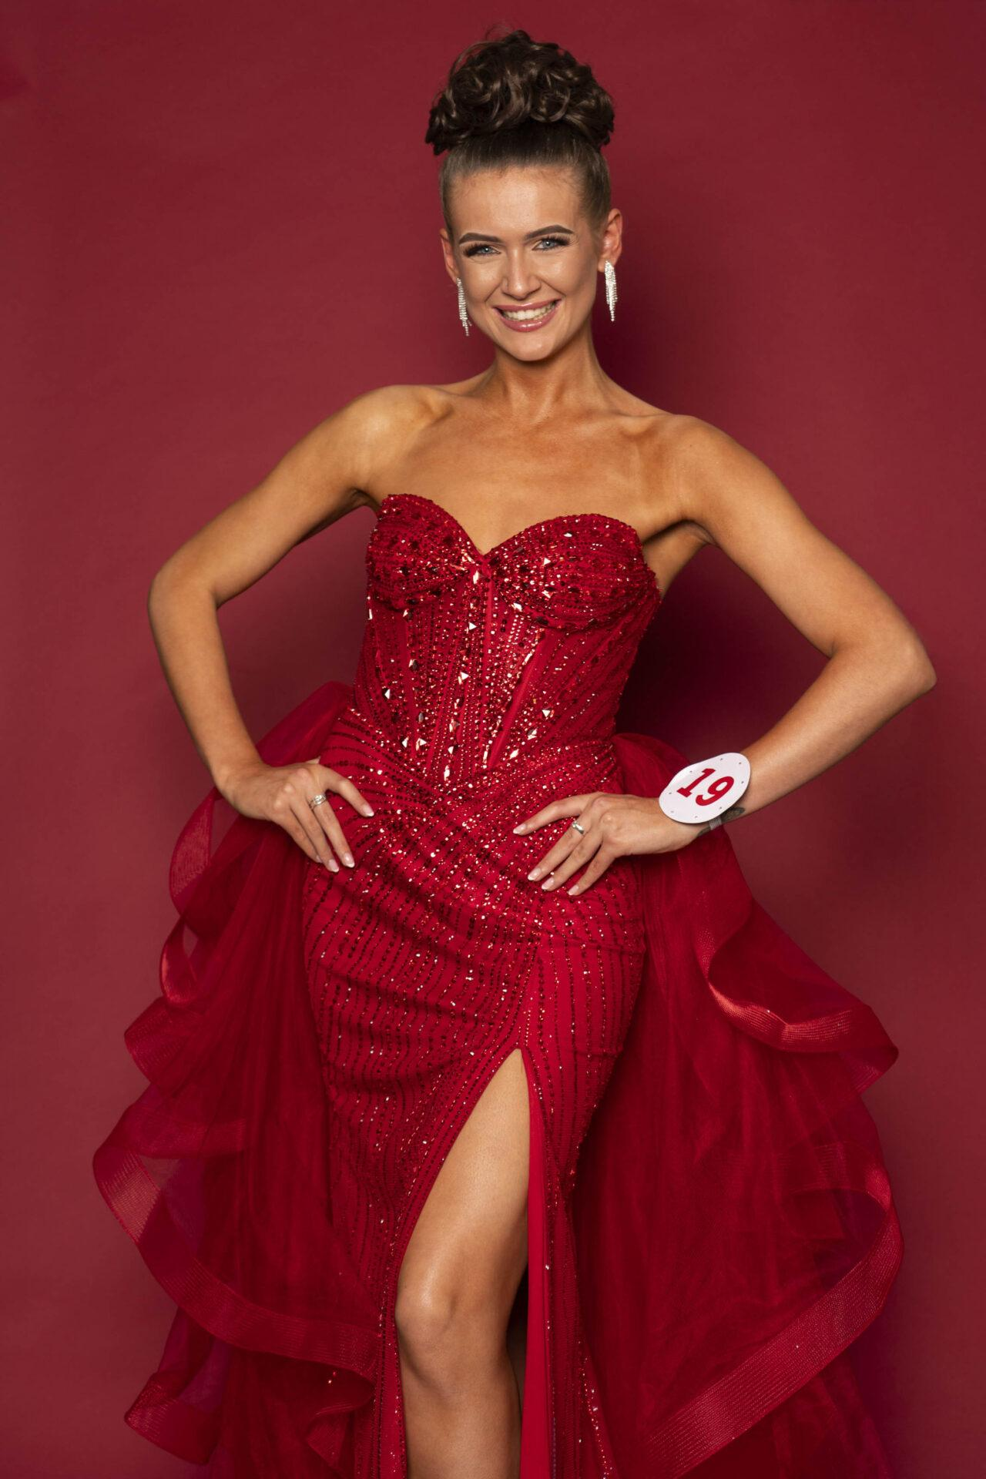
The Miss Norfolk competition will feature a variety of rounds designed to showcase contestants' personalities, achievements, confidence and commitment to charitable causes, culminating in the crowning of the new Miss Norfolk 2026 later this year.

Further information, entry details and competition announcements will be released in the coming weeks through Miss Norfolk's official channels, on Facebook and Instagram: @missnorfolkcontest and online at www.missnorfolk.co.uk. For more information about the Miss England contest can be found by visiting www.missengland.info.

